Linux

free and open source operating system – based on unix

GUI – Graphical user interface
CLI – Command line interface

OS- act as a bridge between Hardware and software

Created by Linux torvis

Distributions – Distros

1.Ubundu
2.Debian
3.Fedora
4.CentOS
5.Arch Linux
6.Kali Linux

Why Linux

1.Free and open source
2.Security
3.Stable
4.Customaizable
5.Power ful CLI
6.Efficient
7.Widespread

Does Linux has virus:
1.yes , but very less
2.Still servers uses the security controls

OS- kernel,Utilities, package managers, bash, GUI Tools
Linux is a kernal

What is kernal:
1. The core engine of the os

Install Linux in windows

1.Goto turn on or off the features

2.Turn on windows subsystem for linux

3. open – terminal and enter : wsl – install
password is ubundu.

Commands:

1.pwd – present working directory ( / home / user_name)
2.uname – a (Linux Panja 6.8.0-52-generic #53~22.04.1-Ubuntu SMP PREEMPT_DYNAMIC Wed Jan 15 19:18:46 UTC 2 x86_64 x86_64 x86_64 GNU/Linux)
3.whoam i
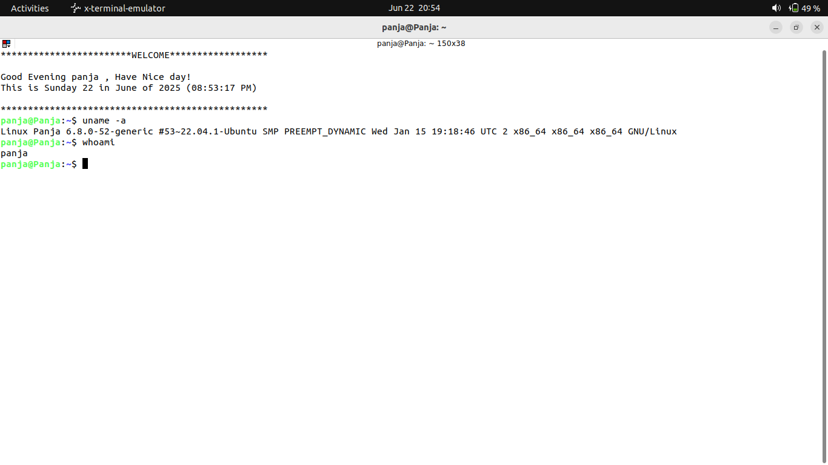

4. ctrl + l or clear to clear the screen.

5.history ( history of the last commands)
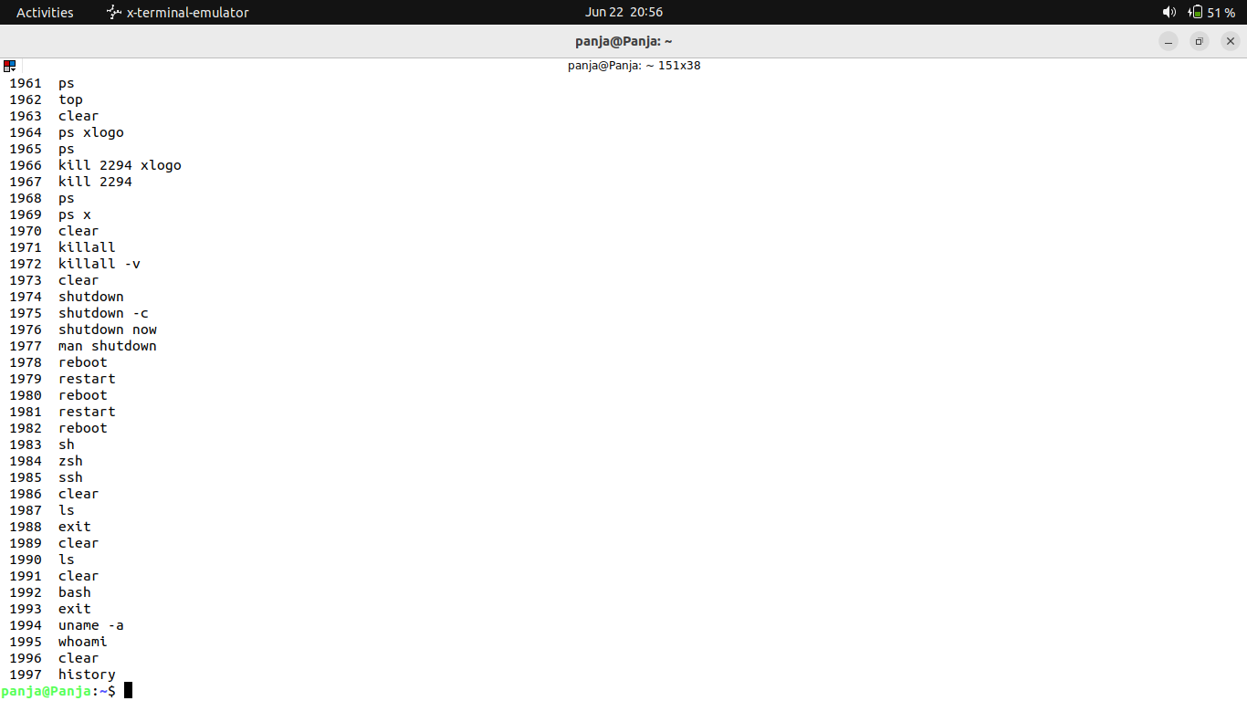
6. mkdir (create a directory)
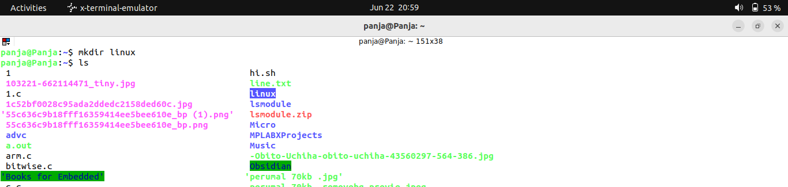
7.install the Notepad++ if you are using windwos
8.cd – change directory
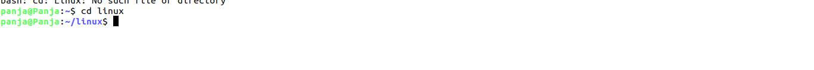

9.vi file_name.file_extension
note(file name must end with the extension also)-just a note

VI commands

i – insert
v- visual
esc - esc mode
in esc mode:
:wq – save and quit
:w – for save
:q – for quit
:q! - quit without save

10.ls – list
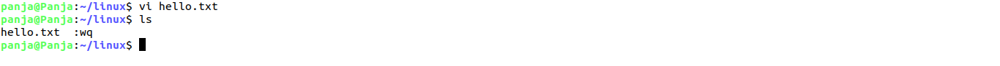

How to install a package:

sudo apt install ___
sudo apt-get install vim

11. press tab to auto complete ex vi h+tab means it will automatically type

12. use vim instead of vi after installthe vim you can use vi

13.select the lines to copy and it will copy when you press the mouse middle button it will paste

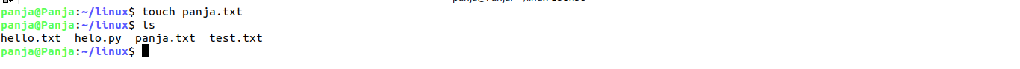
14.touch to create a dummy file
15. rm to remove the file
* - means all

16.cat to view the file

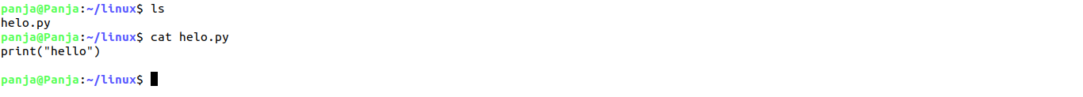
17. cp – copy
cp source destination

18. mv to rename or move

you can use cat command to move or copy the files
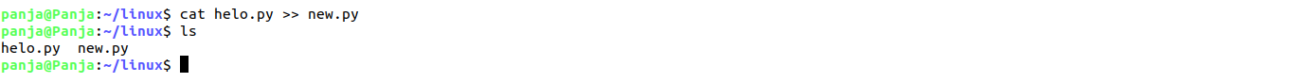
command >> used for append the files

19.echo means print
echo “panja “ >> helo.py
it will add the panja to the last

history >> helo.py - it will append the history command out put to the helo.py file

you can acces the the folder files by giving the exact the path

~ - / home / panja ( we can use ~ tilde symbol instead fo typing full)

mkdir - p to create a parent direcoty
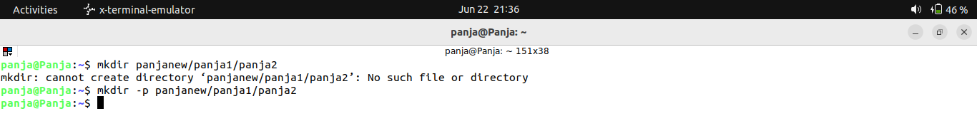
wihtout -p we cannot create a direcoty directly inside a direcoty
if you have a directory you can use it without -p

rmdir – to remove the directory

cd.. to come back to the previous direcory.
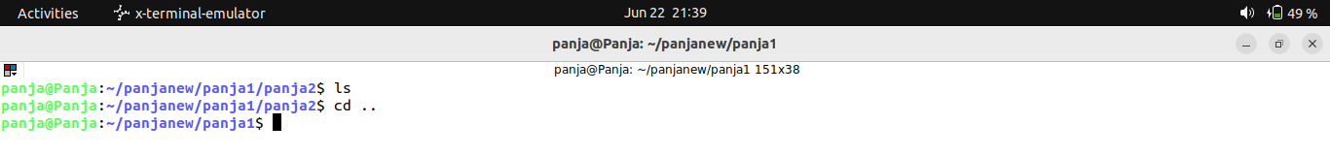
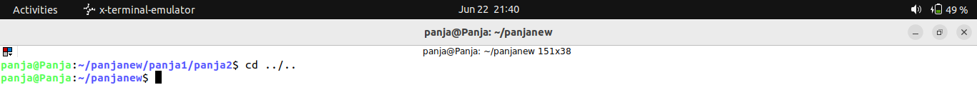
Cd ../.. to come out the two paths
‘cd –‘ to go back to previose file

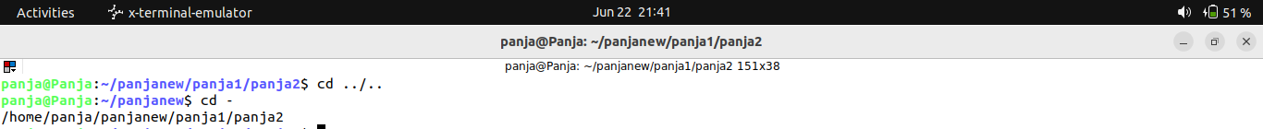
Everything in linux is a file.

Ls
ls-list
ls – lstr

-l – long list format
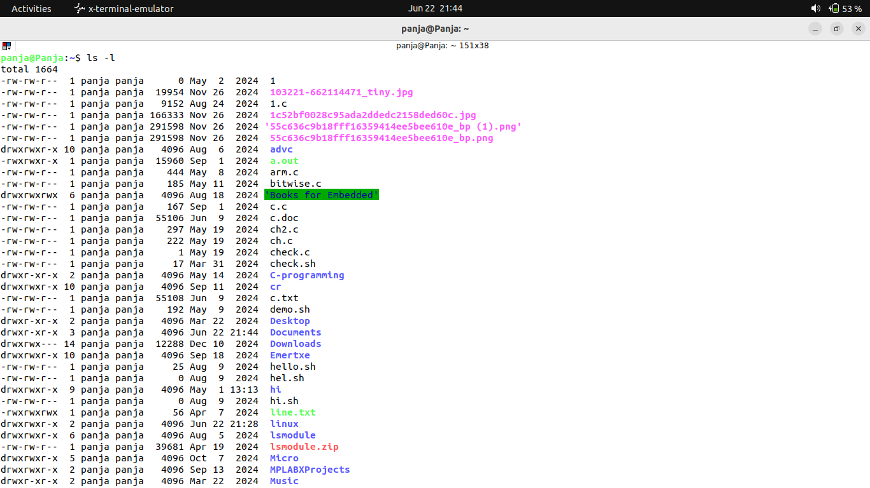
it will have all the datas

-s
shows the file size

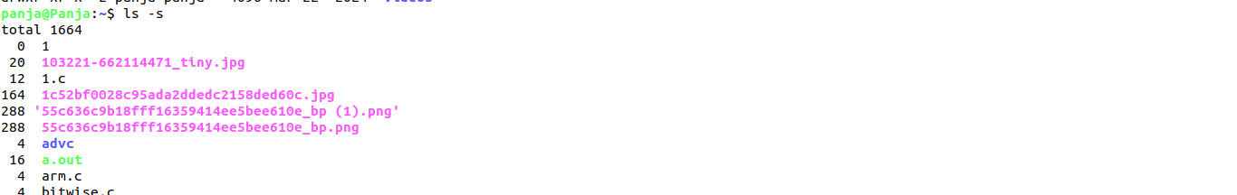
-t sorts by modification time

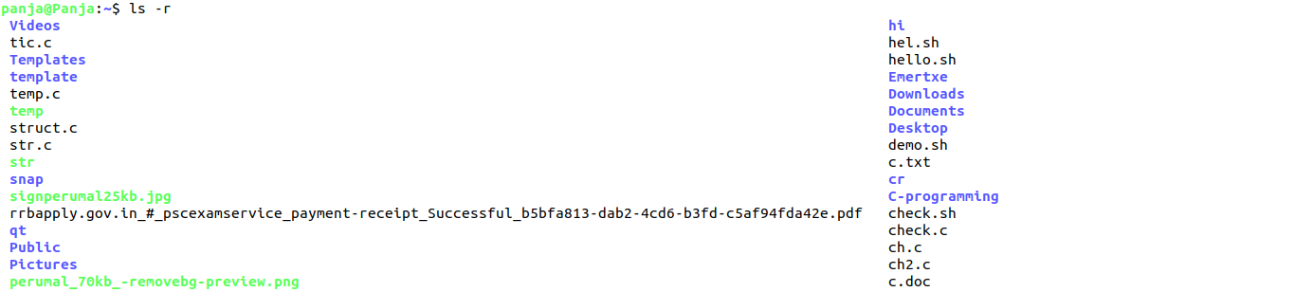
-r – reverse the sorting order

ls – lstr – it includes the above mentioned commands together

ls – a to view all the files – hidden files
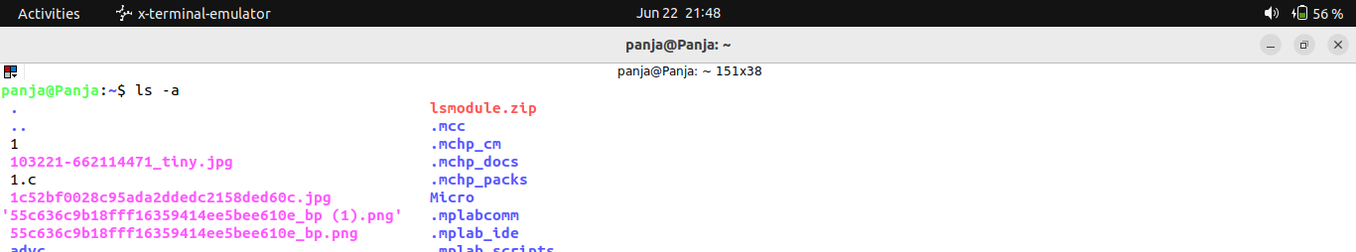

if you create a file starting with . (dot means) it is a hidden file

you have to input the home direcotry inthe bashrc other wise it will not work(ex:if you install python means you have to input the file home path in the bashrc file)

source .bashrc – to run the command
bash .bashrc – to run the command

ls *.txt – it is wild card it will show only .txt files
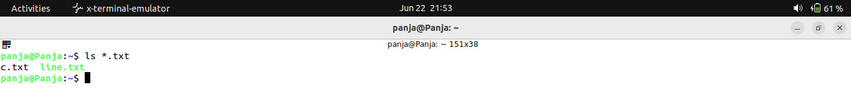

cltrl+c -> to terminate the current task and go to the new line

Hardlink – same content but different file name.

Ln to create a link file
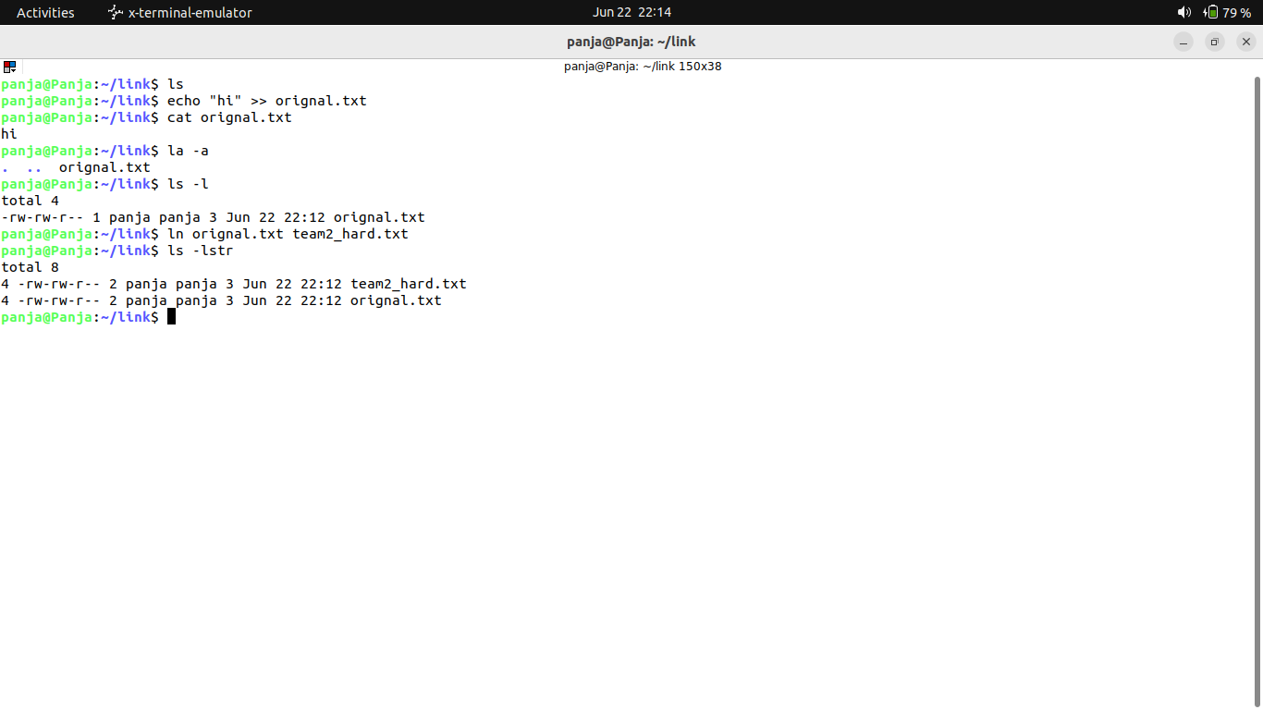
the number 1 shows the one link and in second command the 2 shows the 2 links

If i modify any one files it will affect the both the files
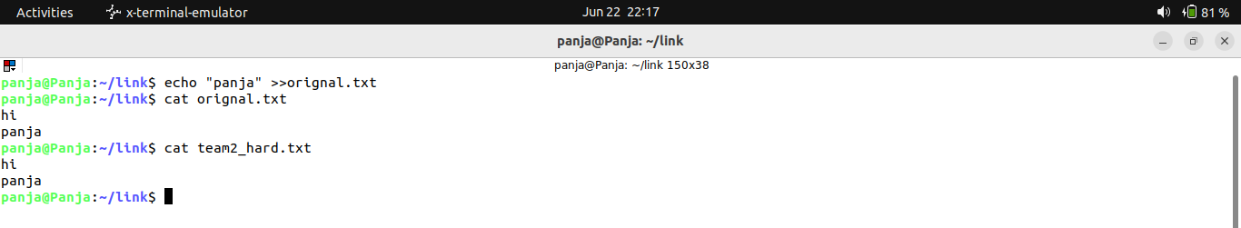
if any one reference deleted means the data will not be removed. The reference only deleted.

Ln-s soft link

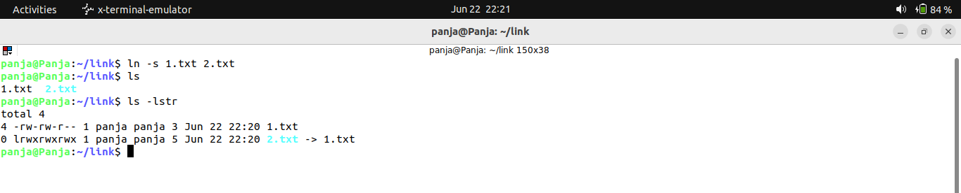
it will not have the 2 hard link it only have 1 link.

If i delete the original file the other data will not work . The data of that also deleted.

Alias – it will create a simple command for a command
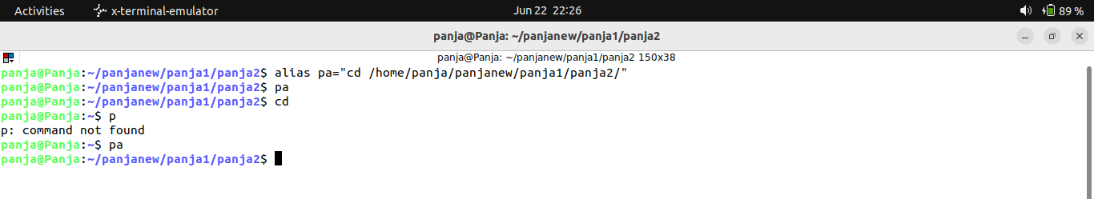
i

it will only work untill i close the terminal

if you want this to be permanent means you need to enter into the .bashrc file

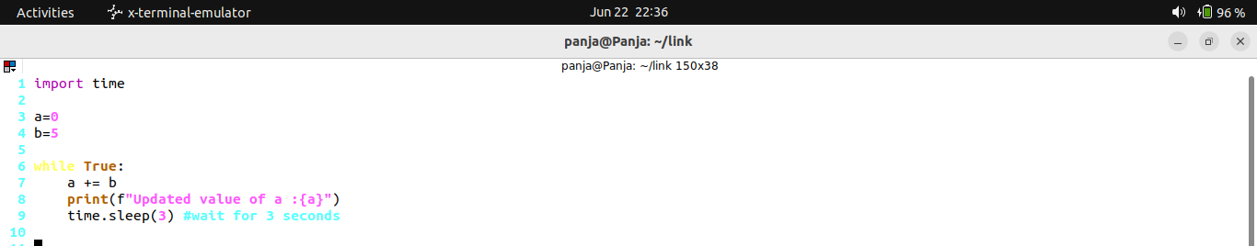
this python commnad will print 5 table every 3 seconds(it will run in foreground)

if i close the terminal it will be terminated
to run the command in background

we are going to use the nohub command
nohup python3 newpython.py >> data_process.log &
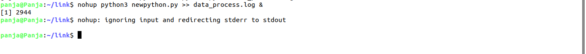
if we shutdown the source(system) it will be killed

top – it is like a task manager
(ctrl+z) to come out
ps – command to check the running commands

ps -aux

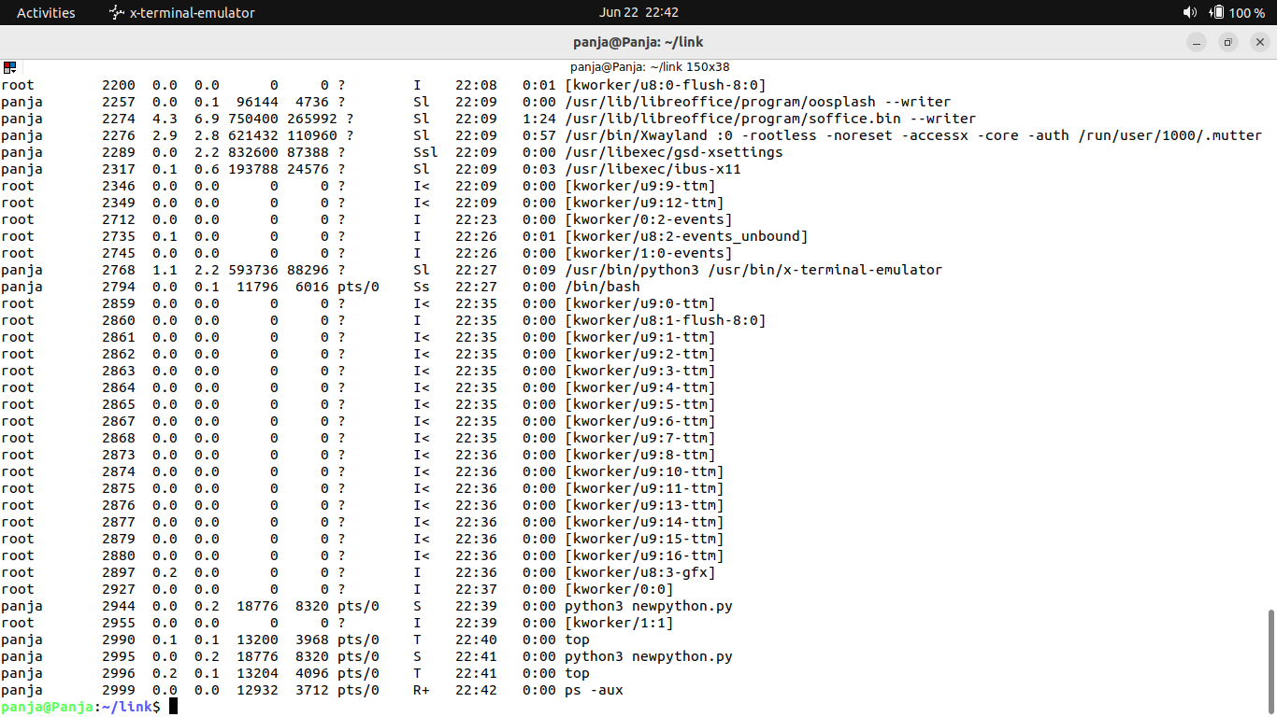
ps – aux
-a show process for all users, not just the current one
-u show the user who own the process and display the user format
x show process not attacjed to a terminal

tail -f it will show the file value even if is updating

to kill it we can use kill command we needto use the PID

kill -9 __PID
enter double time
grep – pattern matching

ps -aux | grep newpython.py
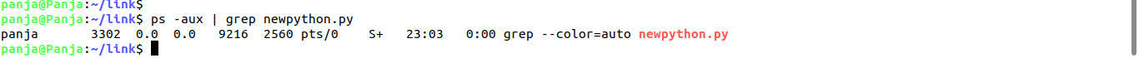

wget – to use download the files
wget file name “https..”

----------------------------------------------------------------------------------------------------------------------------

df -h – disk files as human readable file

du – sh lsmodule/ -> we can see how much storage it is using

to zip the files we can use the command
1.zip
zip -r means all the files in the file

unzip to unzip the files

2.tar

tar -czvf ->to compress it
c-compress
-z all forceable
-v verbose list
-f - following list
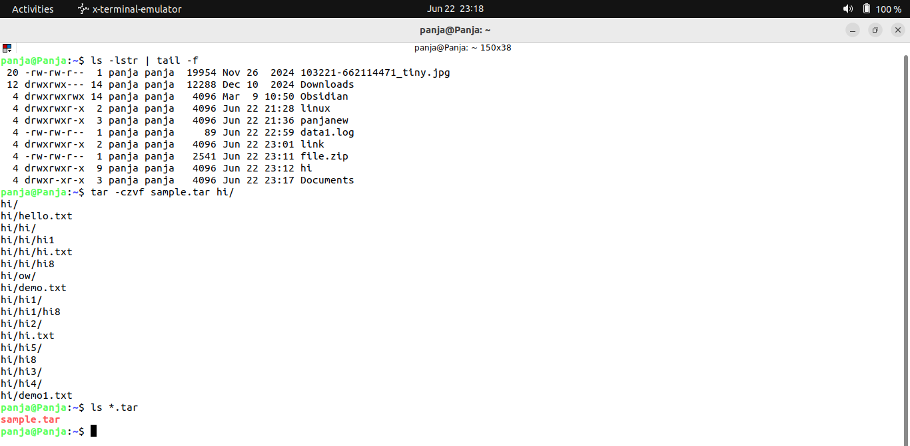

tar -zxvf
x-untar
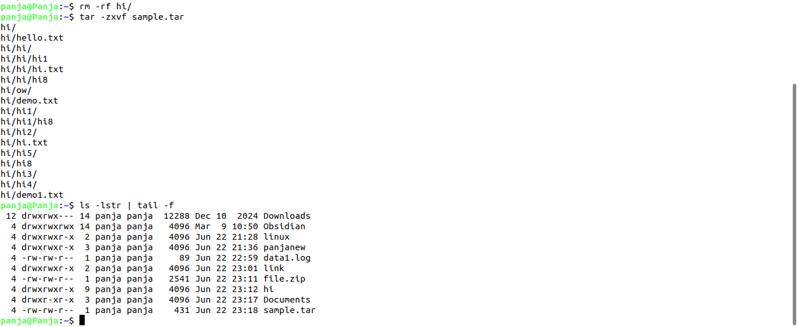

to check the memory

free -m -> to see in mb
free -g -> to see in gb
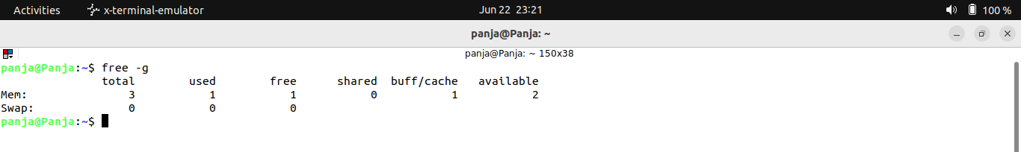

to clear the buff/cache
sudo sh -c “sync; echo 3 > / proc / sys / vm / drop_caches”

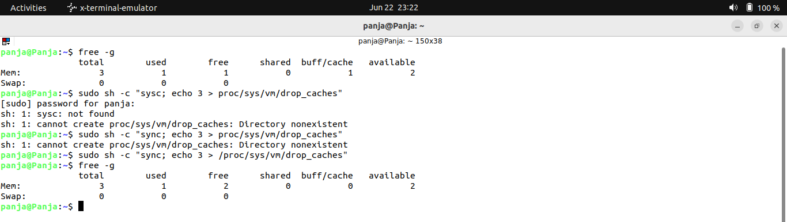

wc - word count

wc file_name
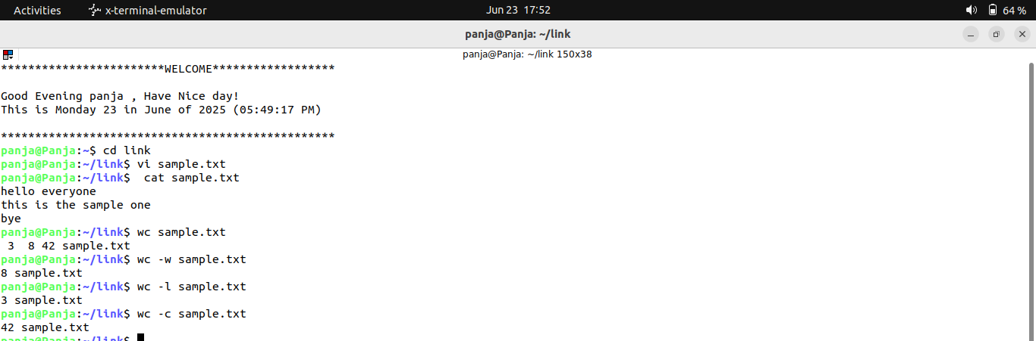
wc – l _> lines
wc -w -> word cound
wc -c -> character count

sort :

sorting in order

sort file_name -> a to z order
sort -r file name -> z to a order
sort -n file name -> number order
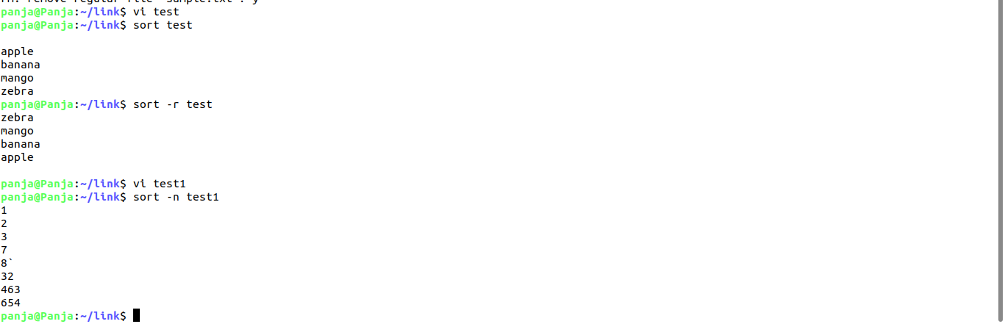

Head :
it shows first 10 lines

head file_name

head -5 file name
it shows only first 5 lines

grep: global regular expression(important)
mostly used for pattern matching

grep ERROR log1.txt
it will show only the exact ERROR items

grep -i search_content file_name

it will search without casesensitive

grep -v ERROR log1.txt
it will omit the ERROR
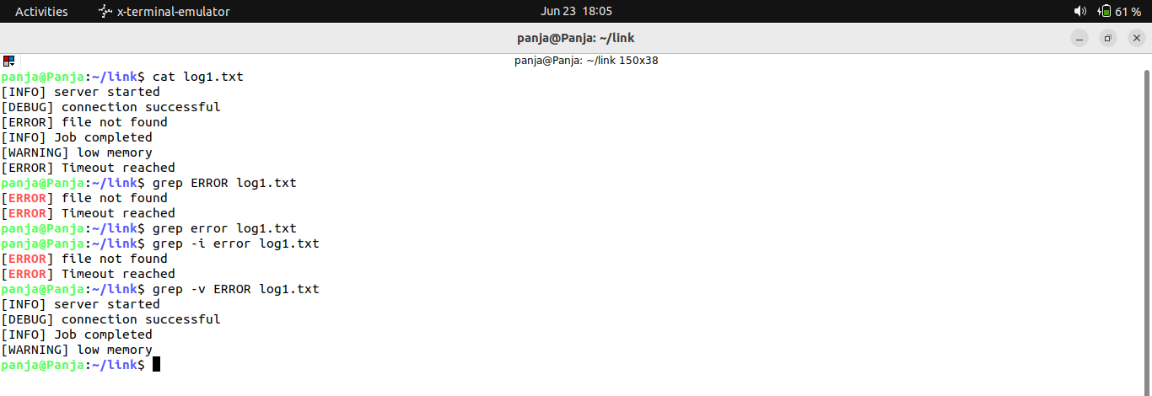

grep -i warning *.txt
it will search the warning in all the files
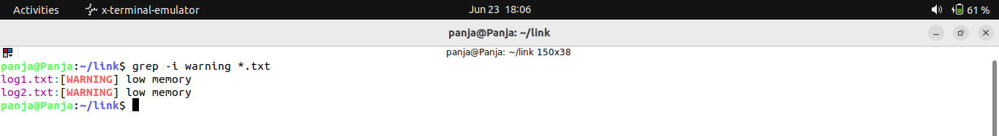
| -> pipe command

grep -i warning *.txt | tail -f

suggested to use it in the command

grep -r to search in recursive
to search in the all the sub folders
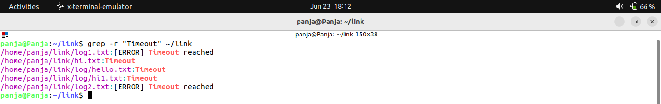
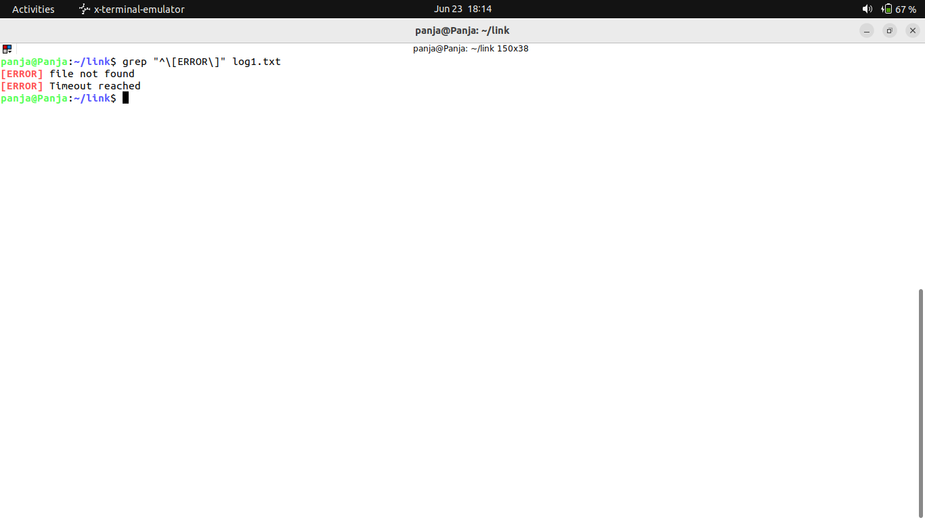
regex :

ssh and scp

ssh – secure shell
scp – secured copy

both are network commands

ifconfig
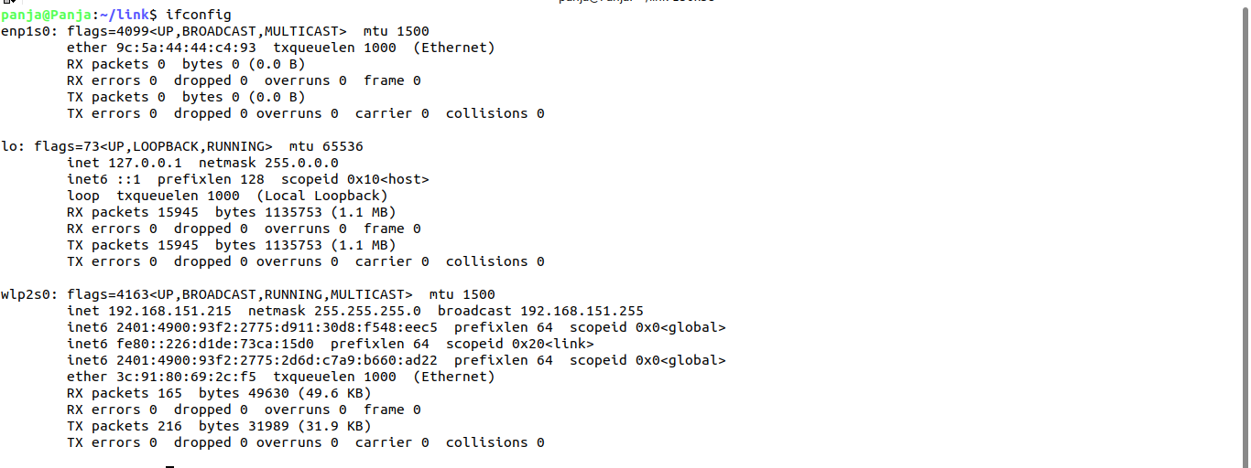
install shh by using sudo apt-get install openssh-server

my ip :192.168.151.215
ssh ip
and then enter yes

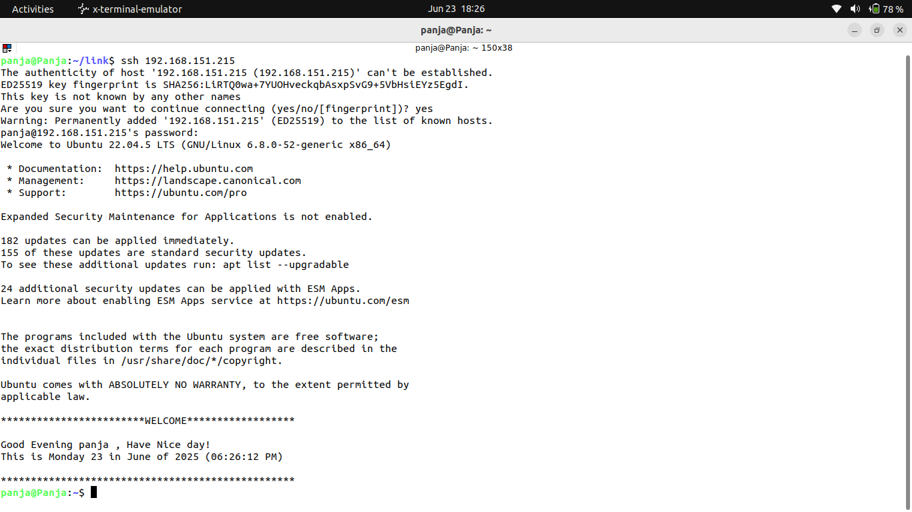
hostname : panja
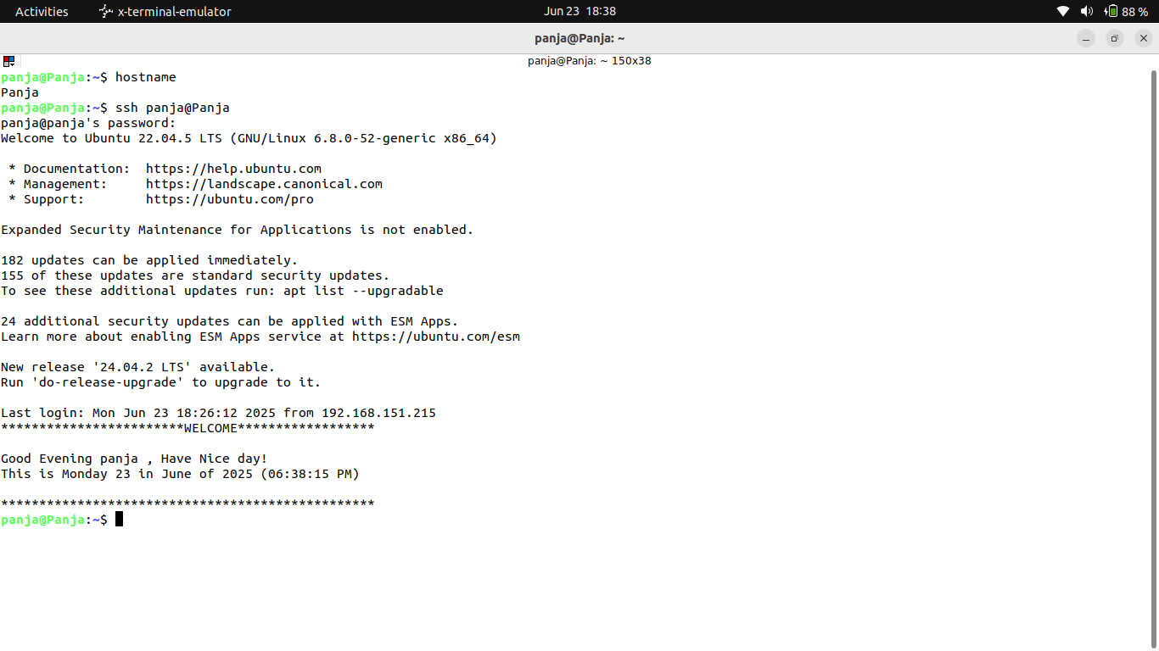
we can use hostname to login the ssh shell

you can connect it in windows using tools
1.putty
2.winscp

these are the main tools
putty used for ssh
and winscp for scp

install putty app
and paste the ip
a black terminal will open
and enter the username
and then enter the password

SCP:

secured copy
to copy files from one system to another system

scp source destination

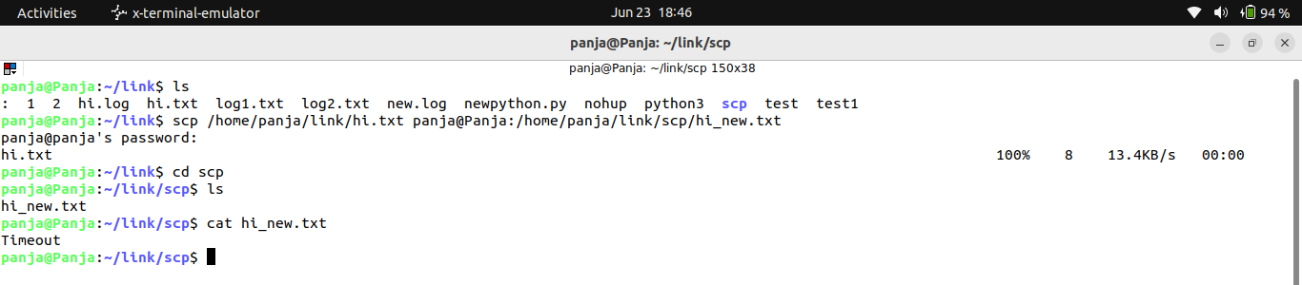
you need enter the desitnation user password here i am using my system only

by using tool

install winscp

open the app

hostname :ip
username :panja
and password : your password

you can see your linux files in the windows files

you can mention putty and winscp in your resume

Need to watch the hadoop video

find :
find . -name log1.txt
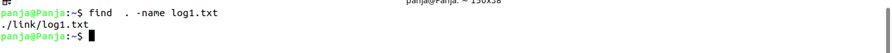
it will search in all the folders also

we can seach using by size, type also

find . -type -f -size +10M
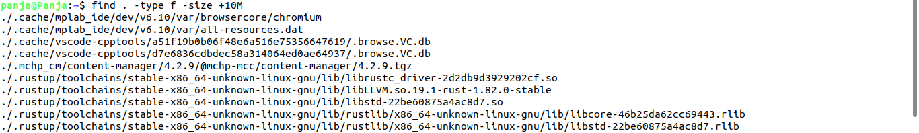

find . -mtime -1
it will show the modified files in the last 24 hours

find . -empty
show all the empty files

find . -name “*.tmp” -delete
it will search all the files end with .tmp file and it will delete all .
We should be more care ful while using these

awk :

awk is a command line tool for

processing colummns in text
performing calculations
extracting and formatting data from files
awk ‘{print} file_name
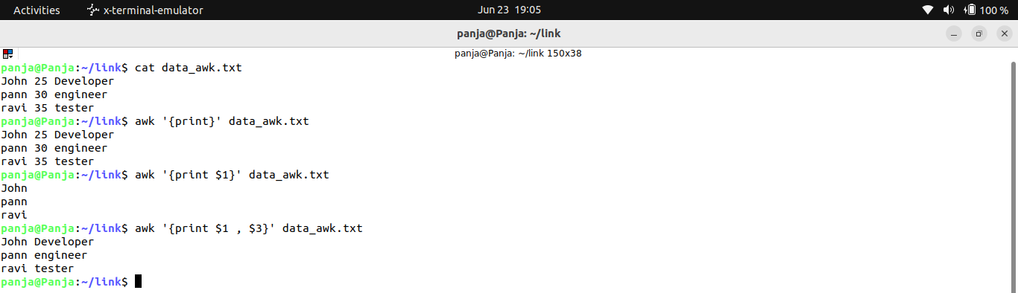
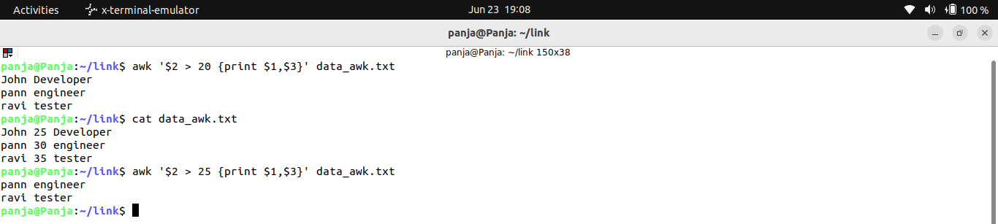
we can filter by the age

we can do output formatting also
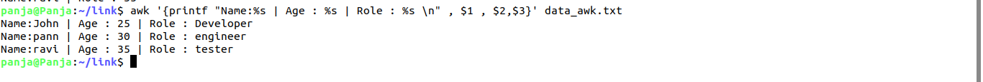

change mode
chmod
user -> The user who own the file
group -> Members of the files group
others -> everyone else “excluding the owner and group”
Root – the super user – not affected by regular file permission

d r w x r – x r – x
d means it is direcoty if it is like – means it is a file
r means user read
w means user write
x menas user executable

next r means group read
x – group execute

other read and other execute
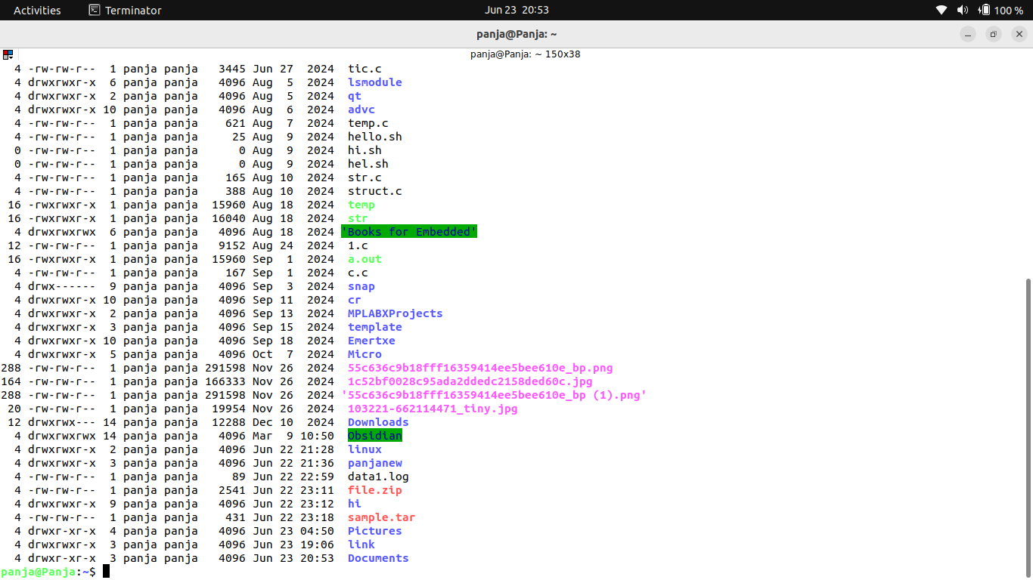
User Group Others
Permission | Symbol | Value
Read | r | 4
write | w | 2
Execute | x | 1

6 = 4+2 ->rw read and write

chmod 755 means
7 -> USER: rwx //read + write+execute
5 – GROUP : rx //read + execute
5- OTHERS : rx / read + execute

generally we dont give 777 to use

chmod -R for the directory

--------------------------------------------------------------------------------------------------------------------

Scheduling
Tools
1.Cron(mac and linux only)
2.Airflow
3.Even while you can use

example
make a python code to capture the time when the script run
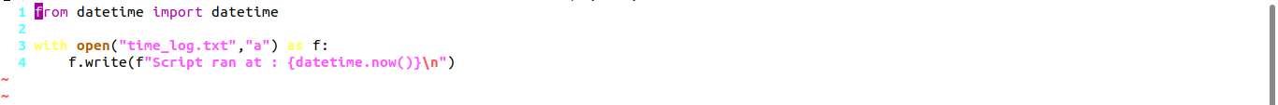

crontab -e
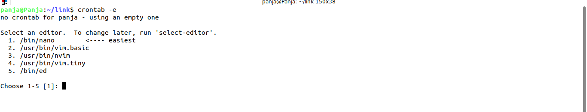

cron formula

*2/****/usr/bin/python3 /home/panja/link/print_time.py >> /home/panja/link/cron_debug.log 2>&1

*2/****/ - this is the corn formula for each 2 seconds it will run the script
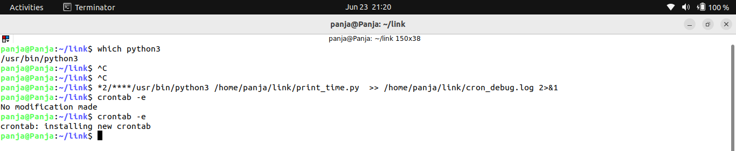
It will open in the nano command
paste the above commnad and enter ctrl x and then chose yes and then enter you will see the installing new crontab

crontab.guru -> we can check the formula
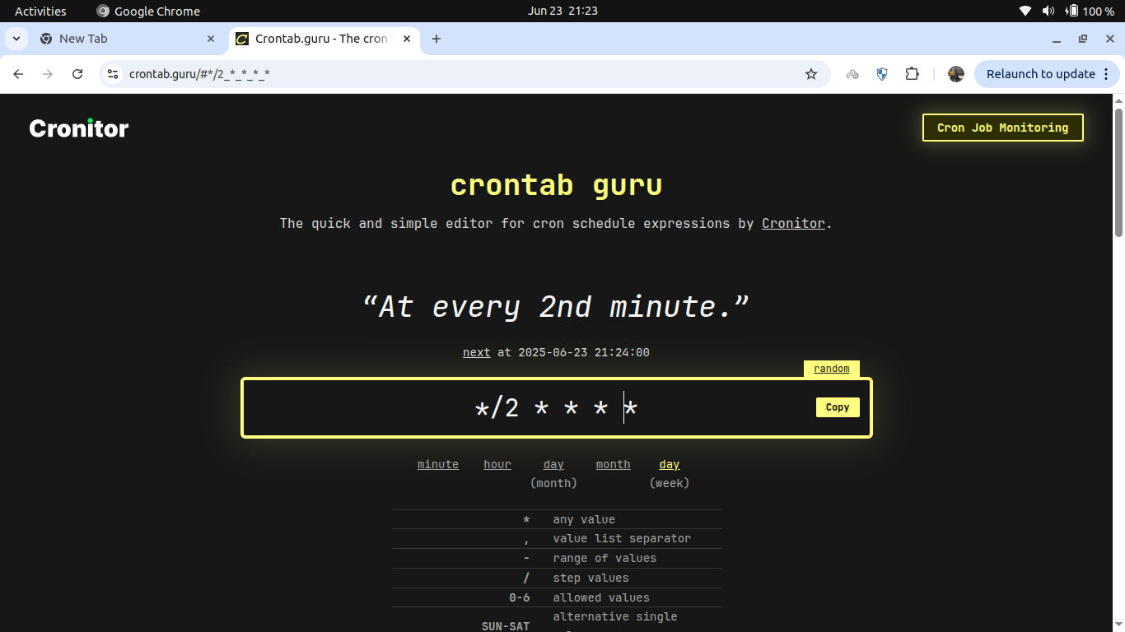

to off it we need to command it. By opening the crontab

Minute | Hour | Day of Month | Month | Day of Week | Command
*/2 | * | * | * | * | /usr/bin/python3 /home/panja/link/print_time.py ...

Virtual env
install the below commnad

sudo apt install virtualenv

and then create a directory
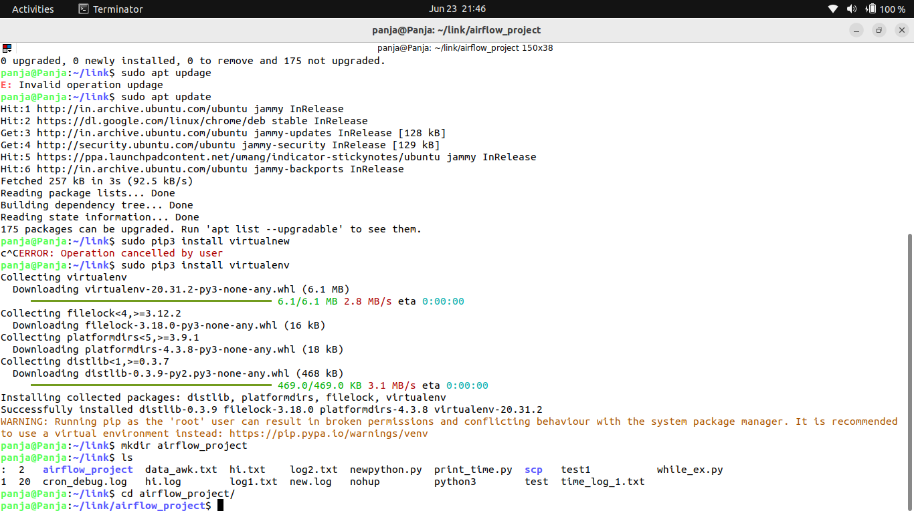
To create a virtual environment

create a virtual environment
virtualenv airflow_venv

then activate

source airflow_venv / bin / activate
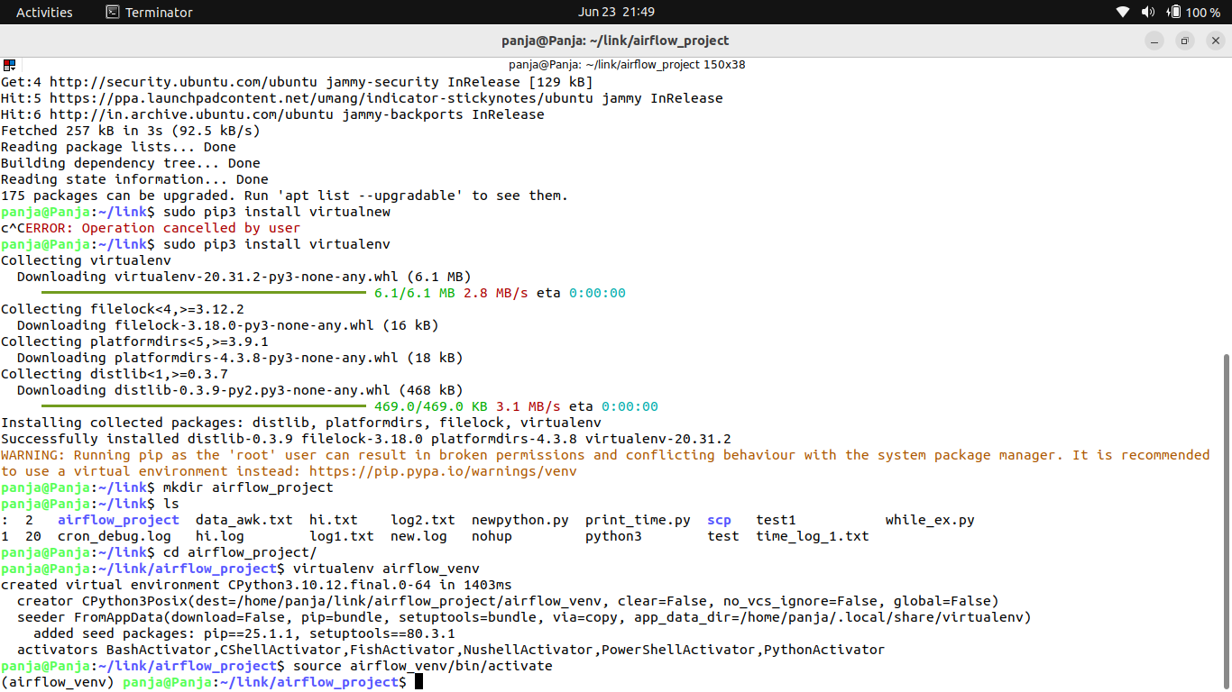

You need to activate every time you open the terminal

AIRFLOW_VERSION=2.6.2
PYTHON_VERSION="$(python --version | cut -d ' ' -f 2 | cut -d '.' -f 1-2)"
CONSTRAINT_URL="https://raw.githubusercontent.com/apache/airflow/constraints-${AIRFLOW_VERSION}/constraints-${PYTHON_VERSION}.txt"

select above command fully and enter
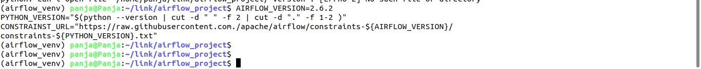

install apache airflow using constraints

pip install "apache-airflow==${AIRFLOW_VERSION}" --constraint "${CONSTRAINT_URL}"

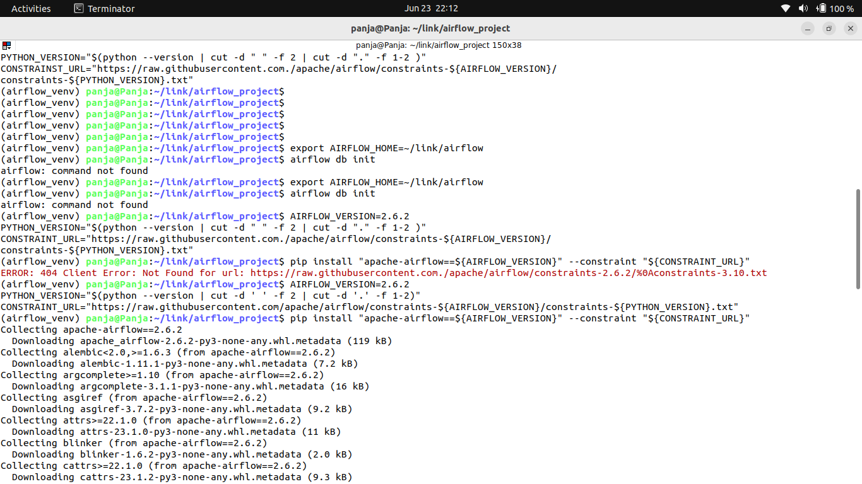

next need to initiate the database

set the airflow home directory
export AIRFLOW_HOME=~/link/airflow

airflow data stored in metadata

next initiate the data base

airflow db init
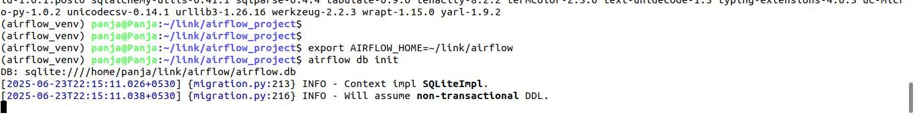

after that we need to start webserver

start the webserver:

airflow webserver –port 8085
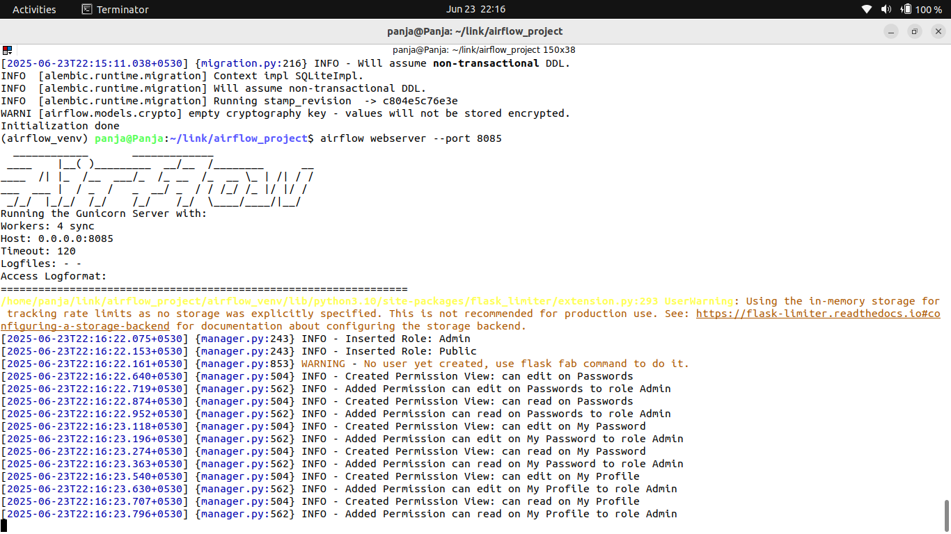

source ~/link/airflow_project/airflow_venv/bin/activate
airflow scheduler

Accessing airflow

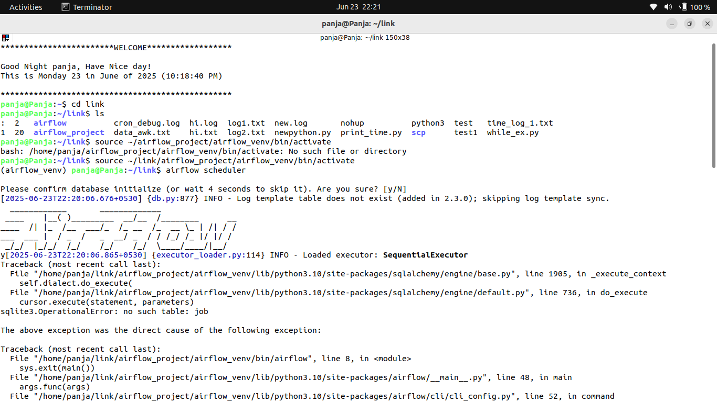

http://localhost:8085

Additional steps
setup the airflow user (optional)

airflow users create \
--username admin \
--firstname panja \
--lastname l \
--role Admin \
--email panja@admin.com



